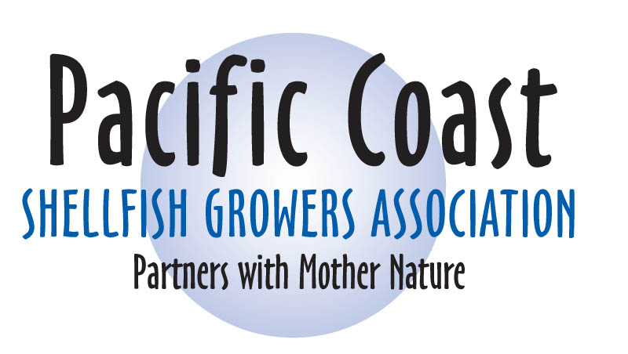

Invitation to Apply

PACIFIC COAST SHELLFISH GROWERS ASSOCIATION
ANNOUNCES

STUDENT SCHOLARSHIP AWARD FOR APPLIED SCIENCE

Deadline: June 1, 2011

The Pacific Coast Shellfish Growers Association (PCSGA) invites students to apply for the Applied Research Student Scholarship Award. Students involved in shellfish biology, aquaculture, marine sciences, marketing or related fields are invited to submit applications for scholarships that award research projects that meet one of the needs for research identified in the Goals 2015 document. This document, produced by the Pacific Shellfish Institute (PSI) and PCSGA, identifies and prioritizes areas of research needed by West Coast shellfish growers. The proposed research should apply directly to one of the priorities for research listed in Goals 2015.

Scholarship awards will vary, according to the applicability of the research, available funds, and number of proposals selected for funding; however, awards are expected to be in the $500 - $1,000 range. Students selected for awards will be expected to present their findings (for completed research) or a description of current or pending research projects at the joint annual conference of the PCSGA and the NSA-PCS September 19 - 22, 2011 in Salem, Oregon.

The award(s) will be presented to the student(s) at the annual Awards Banquet after a presentation of their research at the PCSGA/NSA annual conference. As part of the award, the students’ registration to attend the conference and the Awards Banquet will be covered. Financial assistance to cover lodging costs at the conference site can also be made available.

Any student enrolled in a college or university, including both undergraduate and graduate students, is eligible to apply.

The Goals 2015 document can be found on the PSI website at www.pacshell.org. For further information, contact PCSGA at 360-754-2744.

Completed applications may be submitted by email to: pcsga@pcsga.org or postal service at:
PCSGA, 120 State Avenue NE #142, Olympia, WA, 98501

Application for Applied Research Scholarship Award

NAME: ______________________________________________________________________________

E-MAIL ADDRESS: __________________________________PHONE: _________________________

MAILING ADDRESS: _________________________________________________________________

COLLEGE/UNIVERSITY:______________________________________________________________

DEPARTMENT/FIELD OF STUDY: ______________________________________________________

YEAR IN SCHOOL/DEGREE(S) OBTAINED TO-DATE: ____________________________________

TITLE OF RESEARCH PROJECT: _______________________________________________________

WHICH GOALS 2015 PRIORITY WILL BE OR HAS BEEN ADDRESSED THROUGH YOUR RESEARCH?_________________________________________________________________________

RESEARCH ABSTRACT – ONE PARAGRAPH:

RESEARCH OUTLINE:
(Maximum 3 pages)

Describe your research project, which Goals 2015 priority it addresses, and how specifically the research can be applied as outlined in Goals 2015.

Provide a timeline for your project.

Explain if this is part of an ongoing research project.

INCLUDE AT LEAST TWO LETTERS OF REFERENCE FROM ACADEMIC ADVISORS OR OTHER RESEARCH PROFESSIONALS WHO ARE AFFILITATED WITH YOUR PROJECT OR FAMILIAR WITH YOUR ACADEMIC CAREER.

Completed applications may be submitted by email to: pcsga@pcsga.org or postal service at:
PCSGA, 120 State Avenue NE #142, Olympia, WA, 98501

